using System;

using System.Collections.Generic;

using System.Linq;

using System.Text;

namespace Interview

{

public abstract class Document

{

public string Name { get; set; }

public int Size { get; set; }

public abstract string Display();

}

public enum PixelType

{

Color,

GrayScale,

BlackAndWhite

}

public interface IDocumentProvider

{

IEnumerable<Document> GetDocuments();

}

}

1. Create a class called ImageDocument that inherits from Document.
   1. Add the Following Properties:
      1. public PixelType PixelType { get; set; }
      2. public int FrameCount { get; set; }
2. Create a class called PdfDocument that inherits from ImageDocument.
   1. Add the Following Properties:
      1. public int PdfVersion { get; set; }
3. Create a class called TiffDocument that inherits from ImageDocument.
4. Create a class called PlainTextDocument that inherits from Document.
   1. Add the Following Properties:
      1. public string Text { get; set; }
5. Create a Class call MyDocumentProvider that Implements IDocumentProvider.
   1. MyDocumentProvider should return the following objects.
   2. Create 2 PlainTextDocument with the follow properties.
      1. Name = "Text ABC", Size = 400, Text = "abcdefg"
      2. Name = "Text 123", Size = 12, Text = "123456789"
   3. Create 2 TiffDocument with the follow properties.
      1. Name = "Tiff1", Size = 100, PixelType = PixelType.Color, FrameCount = 10
      2. Name = "Tiff2", Size = 200, PixelType = PixelType.BlackAndWhite, FrameCount = 20
   4. Create 2 PdfDocument with the follow properties.
      1. Name = "Application1", Size = 9000, PixelType = PixelType.BlackAndWhite, FrameCount = 200, PdfVersion=2
      2. Name = "Application2, Size = 3000, PixelType = PixelType.Color, FrameCount = 100, PdfVersion=1
6. Display the all the documents from GetDocuments()
7. Display all the documents from GetDocuments()with size over 200
8. Display all the objects that are PdfDocument from GetDocuments() with Size over 4000.
9. Display all the objects with PixelType = Color.
10. Display all the documents with PdfVersion=2.

Use the Display() to display this information.

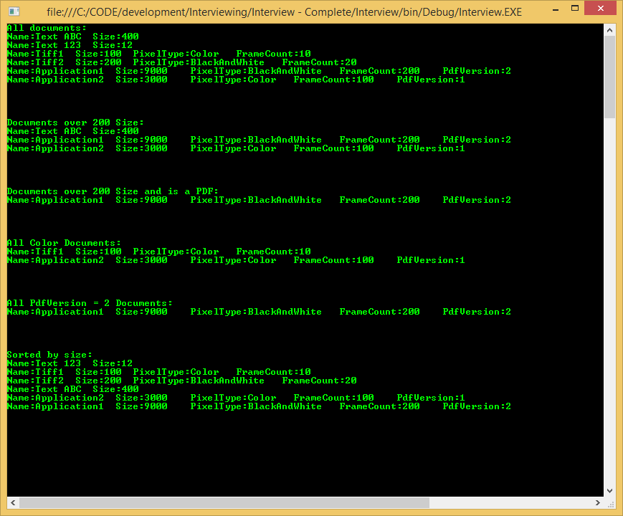

1. Create Either a WPF Project, Winforms project or ASP.NET MVC Project. (OR any Javascript front end framework like Angular, React)
   1. Create a Window/Web Page.
   2. Get a list of Documents from **MyDocumentProvider**
   3. Display the list On the Window.
      1. If Using WPF, Use a DataTemplate to display the documents.
      2. If Using WinForms or ASPX, way to display the list is acceptable.